Lab4 - Guideline

Topics
- Commands – routing table
- IPv4; Static routing; Default route
- IPv6; Static routing; Default route

- Commands – routing table

Netstat and route commands
nestat –rn
route print
route –Cn
route add
route del

- IPv4 – use routers 2811 and add one NM-2FE2W interface in the Physical tab

Laboratory test configuration:

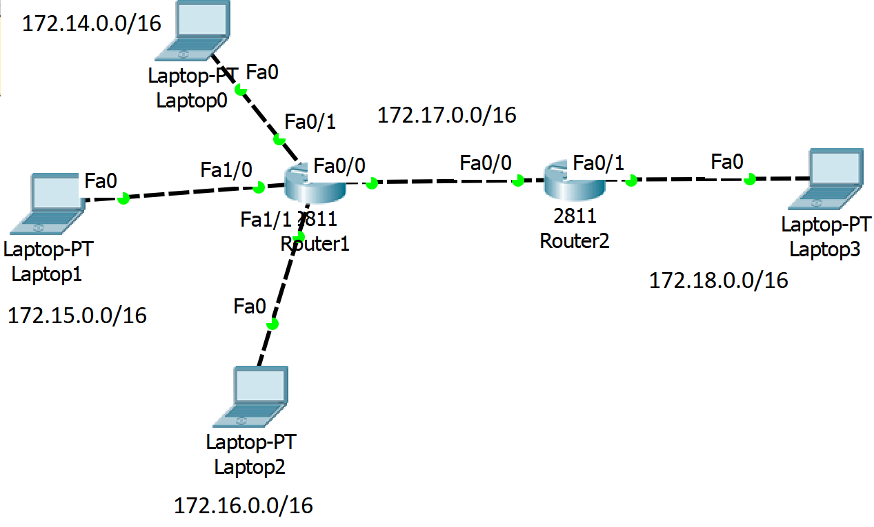

Step1: Assign static IPv4 addresses to routers’ interfaces

Router1(config)#interface fastethernet 0/0
Router1(config-if)#ip address 172.16.0.1 255.255.0.0
Router1(config-if)#no shutdown
Description: Add an IP address on Fa0/0subinterface

Step2: Set static routes

General syntax:
Router(config)#ip route netw_dest_address netw_mask next_hop_address/interface

Router1(config)#ip route 172.18.0.0 255.255.0.0 172.17.0.2

Router1 #show ip route
Description: Visualize the routing table

Step3: Assign static IPv4 addresses to the computers (IP, Subnet mask, Gateway)

Test the connectivity.
  - ping <target IP>
  - tracert <target IP>

Step4:
Delete previous defined static routes on Router2 and add only one network that will offer connectivity with all the other networks.
Router2(config)#no ip route ….

HINT: summarize (using supernetting technique) the networks attached to Router1 172.14.0.0/16, 172.15.0.0/16, 172.16.0.0/16, so that only one network will be advertise to Router2.

Test the connectivity.
- ping <target IP>
- tracert <target IP>

- IPv6

IPv6 has 128-bit source and destination addresses

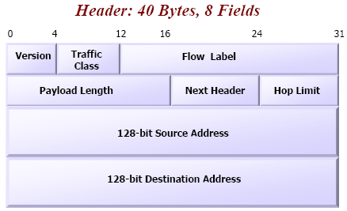
IPv6 header

An IPv6 address is formed by two entities: prefix and interface id

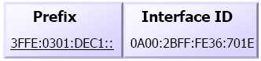

IPv6 Addresses:
- Unicast, Multicast, Anycast

Unicast Addresses
- global
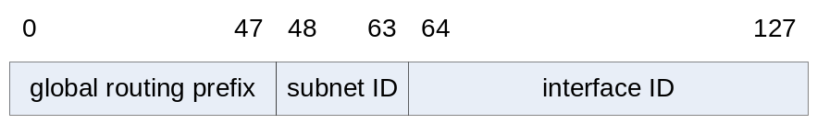
- private
  - Link local (for a link, used for address configuration, neighbor discovery):
stars with FE80::/10 - FEB0::/10 prefix
  - Site local (for an organization):
stars with FEC0::/10 - FEF0::/10 prefix

Adresele Multicast
0 7 | 8 11 | 12 15 | 16 127
Indicator (FF) | Flags 000T (transient flag) | Scope ID | Group ID
FF | IF T =0 well known multicast (permanent)  IF T =1 transient | node-local=1, link-local=2, site-local=5, organization-local=8, global=14
- Well-known Multicast Groups
  - solicited-node
  - all nodes
  - all routers

Anycast Addresses
- “send to any one member of this group”

Global addresses auto-configuration
- Stateless – router
  - Link-Local Address Generation
  - Link-Local Address Uniqueness Test: sends a Neighbor Solicitation message using the Neighbor Discovery (ND) protocol to check if it is unique
  - Link-Local Address Assignment
  - Router Contact
    - listening for Router Advertisement messages sent periodically by routers or
    - by sending a specific Router Solicitation to ask a router for information
  - Router Direction: specifica daca e retea statefull spunand adresa DHCP server sau trimite prefixul, daca e stateless
  - Global Address Configuration
- Statefull - DHCPv6

Laboratory test configuration:

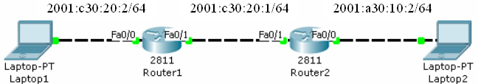

Step0:
Router(config)#ipv6 unicast-routing
Description: enable the forwarding of IPv6 packets between interfaces on the router

Step1: Assign static IPv6 addresses to routers’ interfaces

General syntax:
Router(config-if)#ipv6 address ipv6-address/prefix-length [eui-64]

Router1(config)#interface fastEthernet 0/0
Router1(config-if)#ipv6 address 2001:C30:20:2::/64 eui-64
Router1(config-if)#no shutdown

or

Router1(config)#interface fastEthernet 0/0
Router1(config-if)#ipv6 address 2001:C30:20:2:209:7CFF:FE4D:1501/64
Router1(config-if)#no shutdown

Router#show ipv6 interface fastEthernet 0/0
Description: Visualize IPv6 addresses assigned to the interface

Step2: Set static routes

General syntax:
Router(config)#ipv6 route ipv6-prefix/prefix-length next_hop_ipv6 address/interface

Router(config)# ipv6 route 2001:A30:10:2::/64 2001:C30:20:1:290:2BFF:FE71:6702
Description: configure a static route to 2001:A30:10:2::/64 network

!Important! The Next_Hop_IPv6_address can be seen by executing the show ipv6 interface fastEthernet 0/x on the next hop interface (neighbor router)

Router#show ipv6 route
Description: Visualize the routing table

Step3: Assign static IPv6 addresses to the computers (IPv6, Gateway)

Test the connectivity.

  - ping <target IP>
  - tracert <target IP>

